1)Create an RDS for the jars with the required specifications and the engine as PostgreSQL.

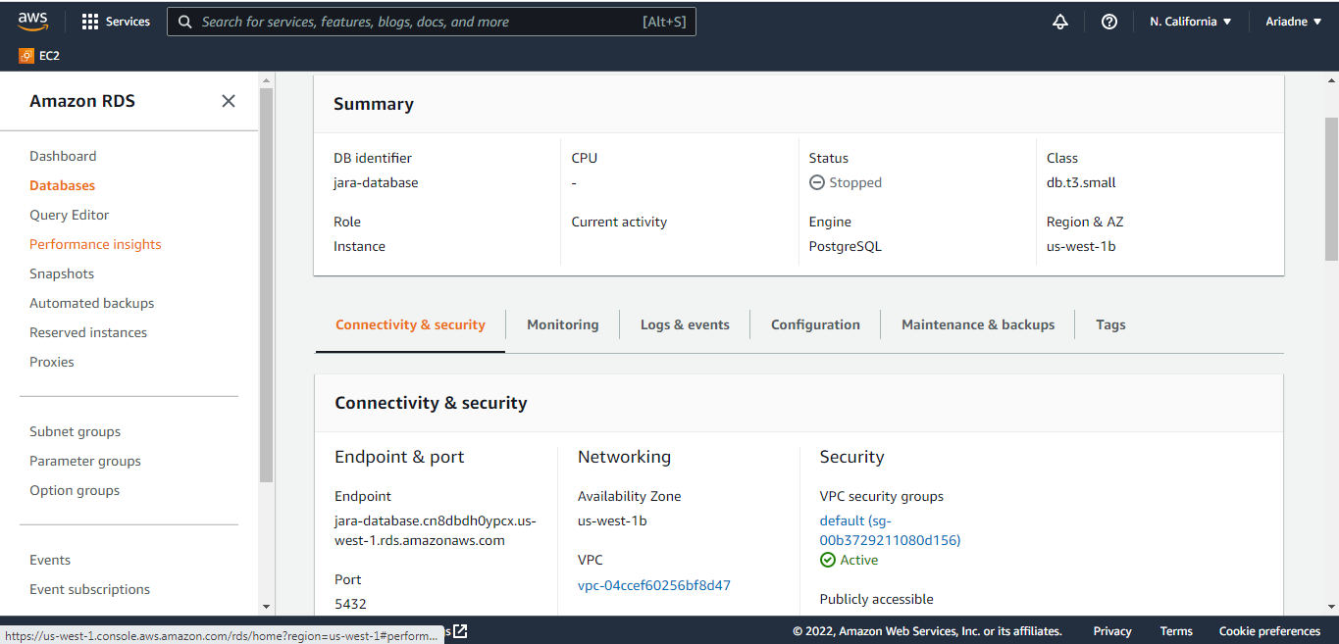

2)Take the rds endpoint and copy it in the application.properties of login jar,userdetails jar and application.yml of zull server jar and MFFProfileservice jar along with portno 5432(postgresql rds portno).

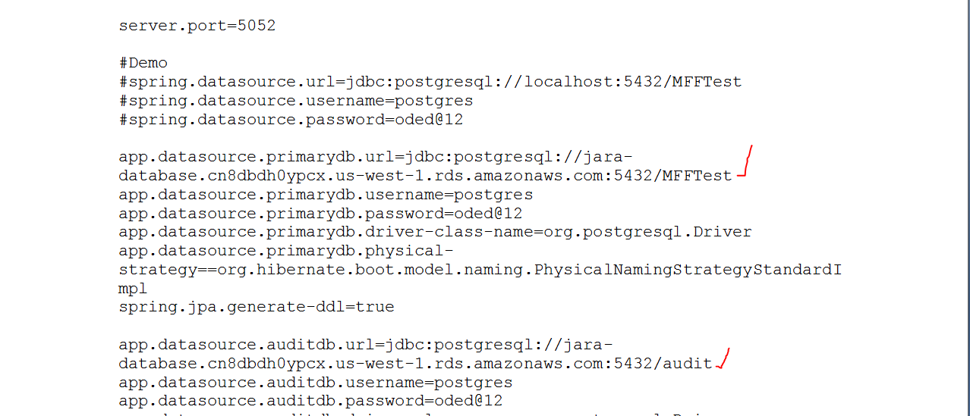

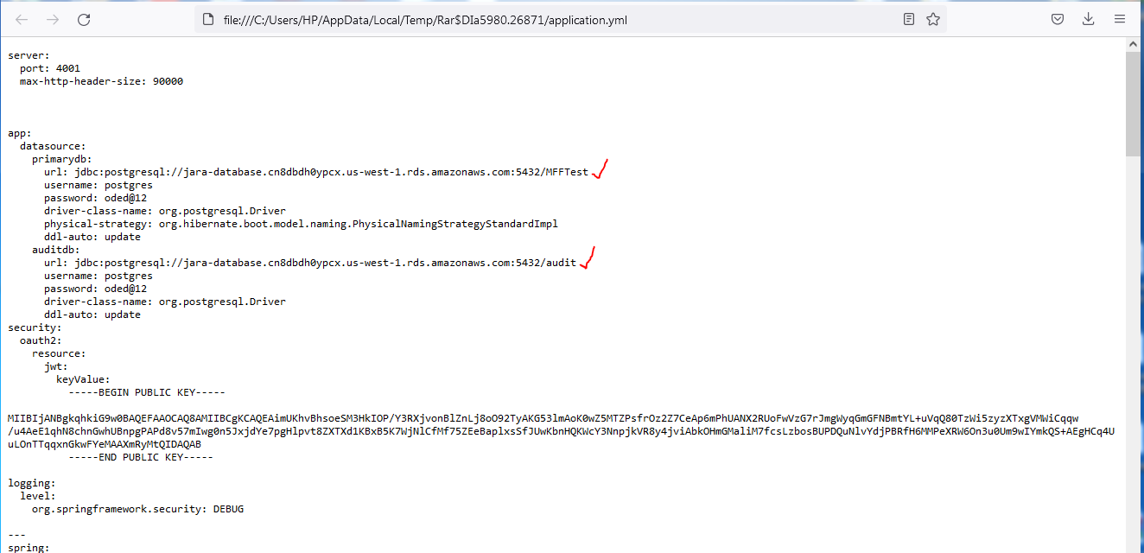

3)Zull server jar which is the main jar is given port no as 5000 because elasticbeanstalk works on 5000 portno.And the other jars login,user and profile are given 5052,7181,4001 ports respectively.Or login user and profile can also be given as 5100,5200,5300.

4)Create a procfile for the jars for the multiple jars to host in elasticbean stalk.

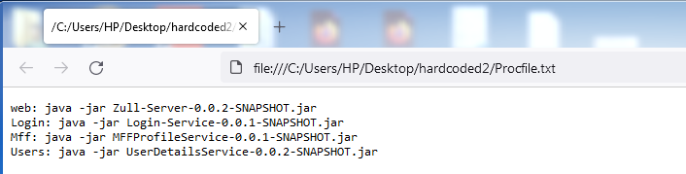

5)Create a .ebextensions folder. And add cloudwatch configuration files for metric and alarms inside .ebextensiond folder.

6)Create a zip file which includes all the jars,procfile and .ebextensions folder.And that zip file is called as sourcebundle.

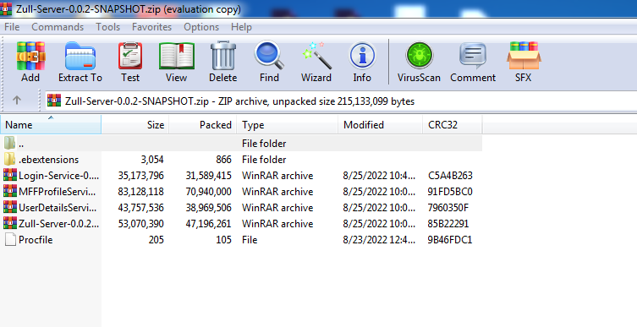

Note: Please note that .txt extension is not allowed for Procfile inside zip folder and Procfile is case-sensitive.

6)Now upload the source bundle(zipfile) in elasticbeanstalk by selecting plarform as java and and platform branch as corretto 8.

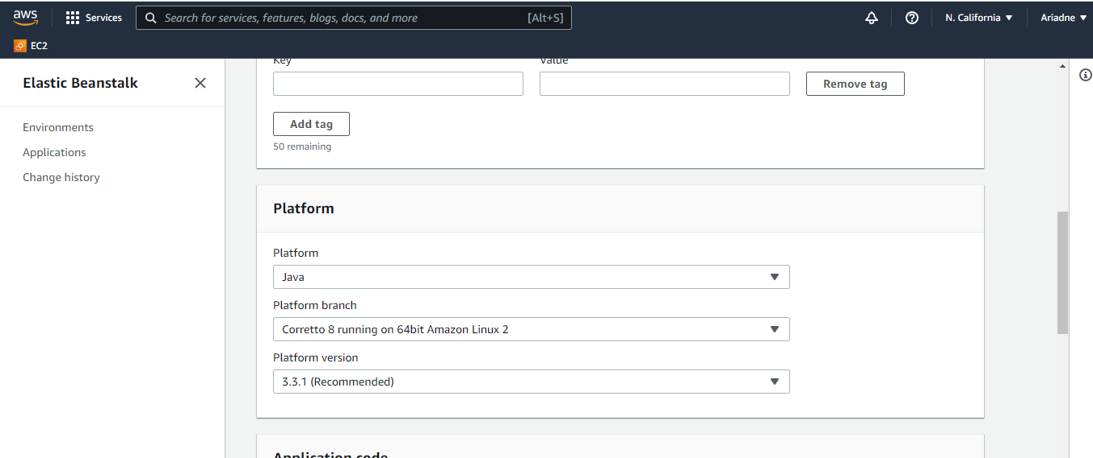

7)See that in the environment properties of software configuration no port no is given.

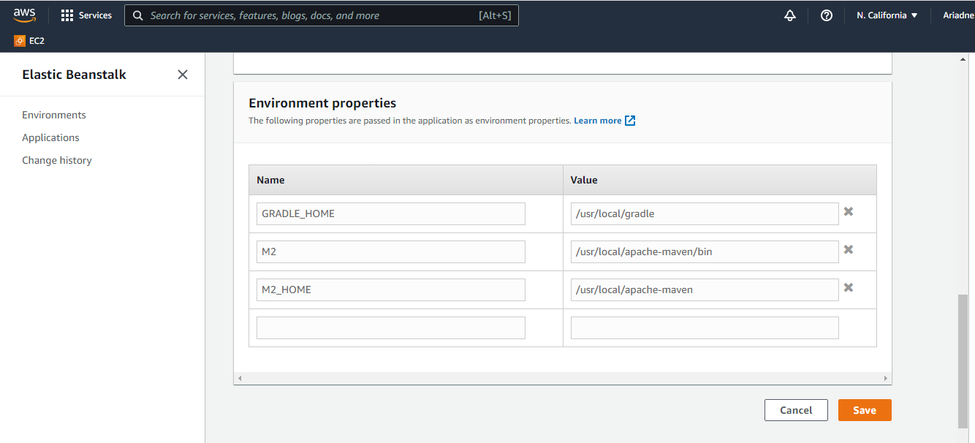 8)In the Configuration of autoscaling group select environment type as load balanced where we can select min and max instances.And the instance type as you required.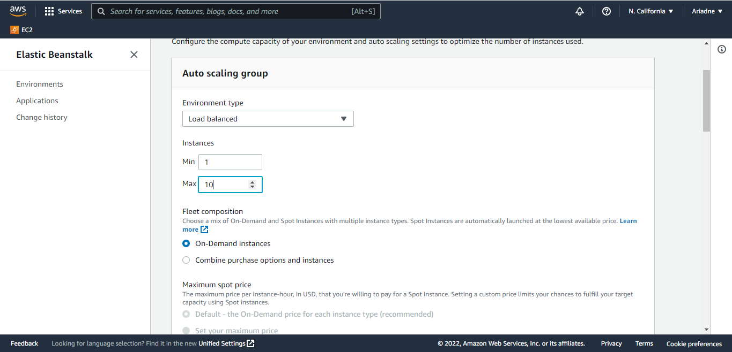

9)In the security configuration add the ec2 key pair so we can ssh into to the servers using putty.And iam istance profile should be selected as aws-elasticbeanstalk-ec2-role.And elasticbeanstalk ec2 role should be attached with cloudwatch agent server policy so that the role will have permission to use the cloudwatch agent inside the server.

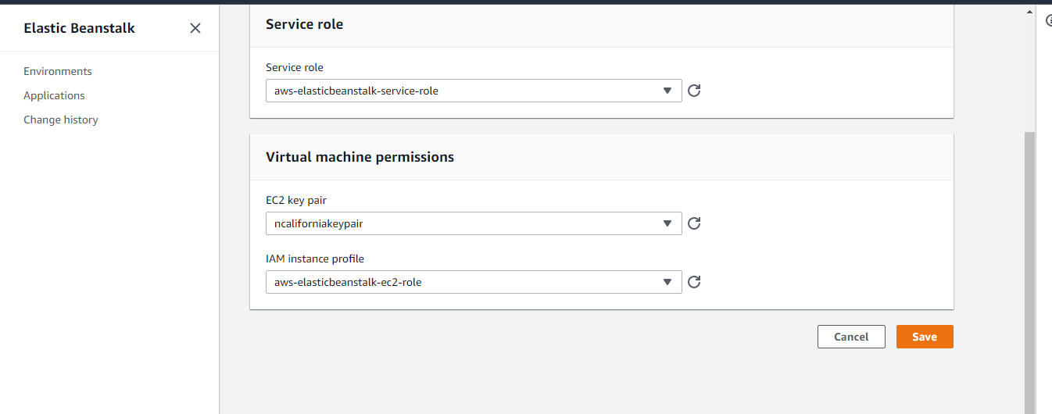

10)After saving all the configurations the elastic bean stalk environment is created along with the cloudwatch alarms and metrics of memory utilization(memory used percent) where we will monitor the memory.

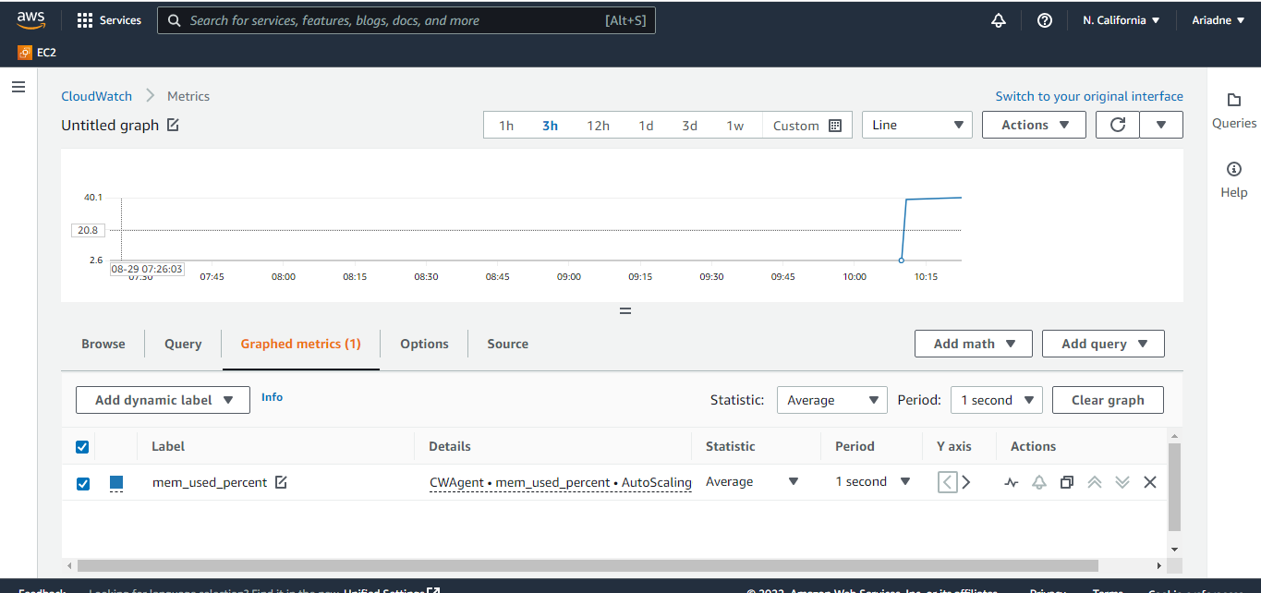

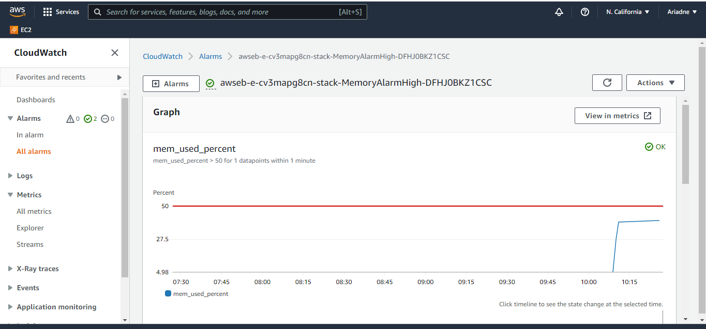

11)Create the dynamic scaling policies for the autoscaling group created through elasticbean stalk.These dynamic scaling policies takes the help of cloudwatch alrms to scale-out and scale-in of instances.

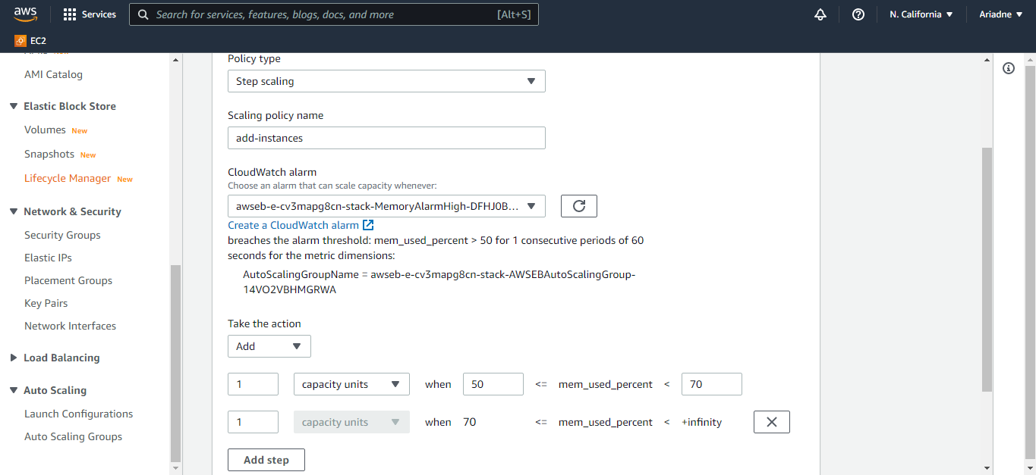

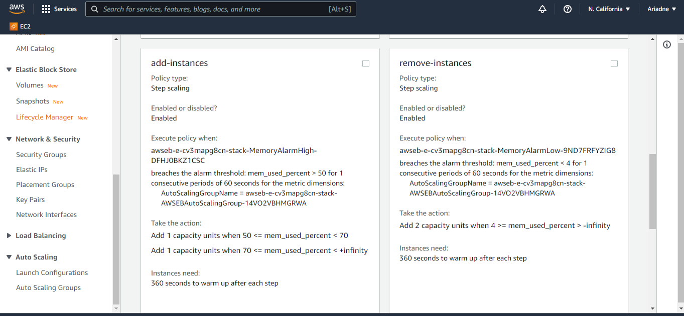

12)A new server will be scaled up when the memory used percent(utilization) reaches more than 50 percent.

13)We can monitor the activities section of autoscaling group to know scaling out and scaling in of the instances inside autoscaling group.

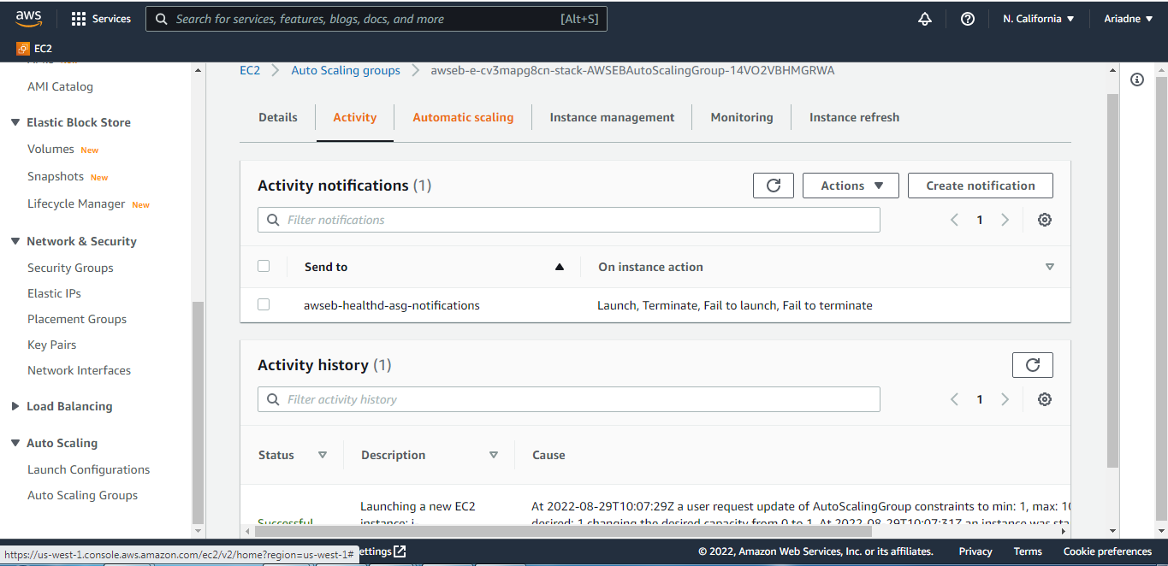

14)The main server where the application resides can be given scale-in protection if requires.So that this server will n ot be terminated while scaling down(scale-in) is happening.

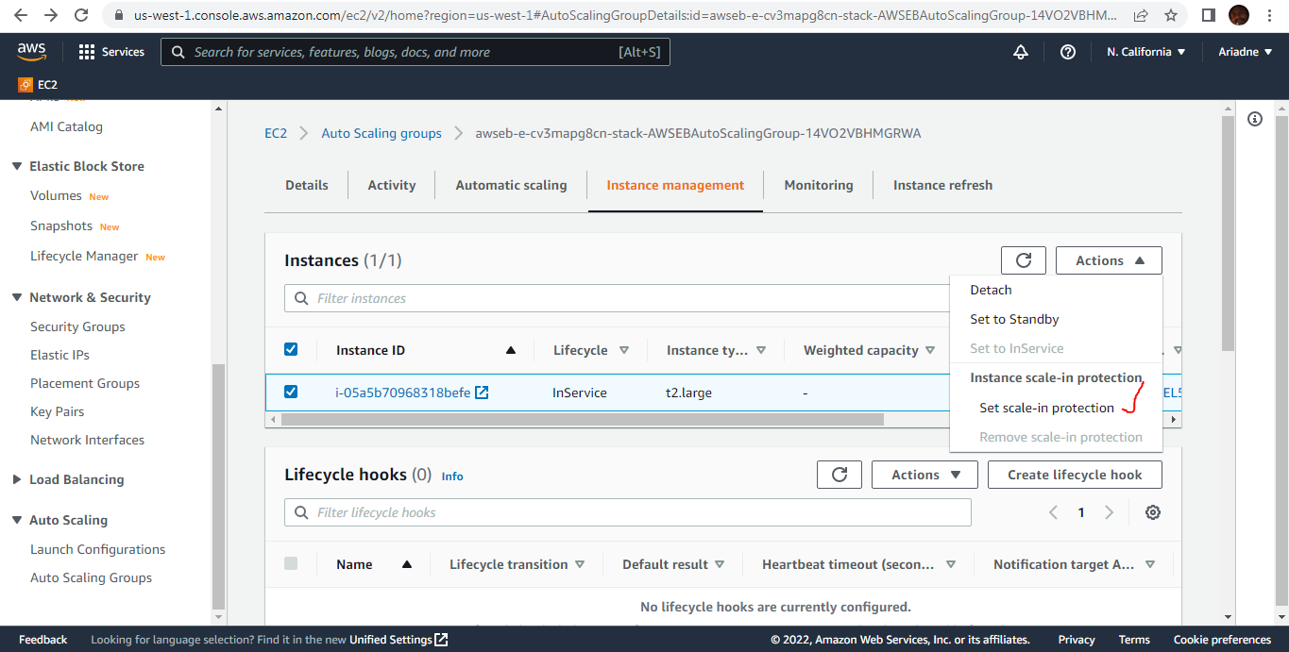

OUTPUT:

We can see that the memory is getting utilised in 2 servers.(red terminal is newly scaled up server and white terminal is initial server)

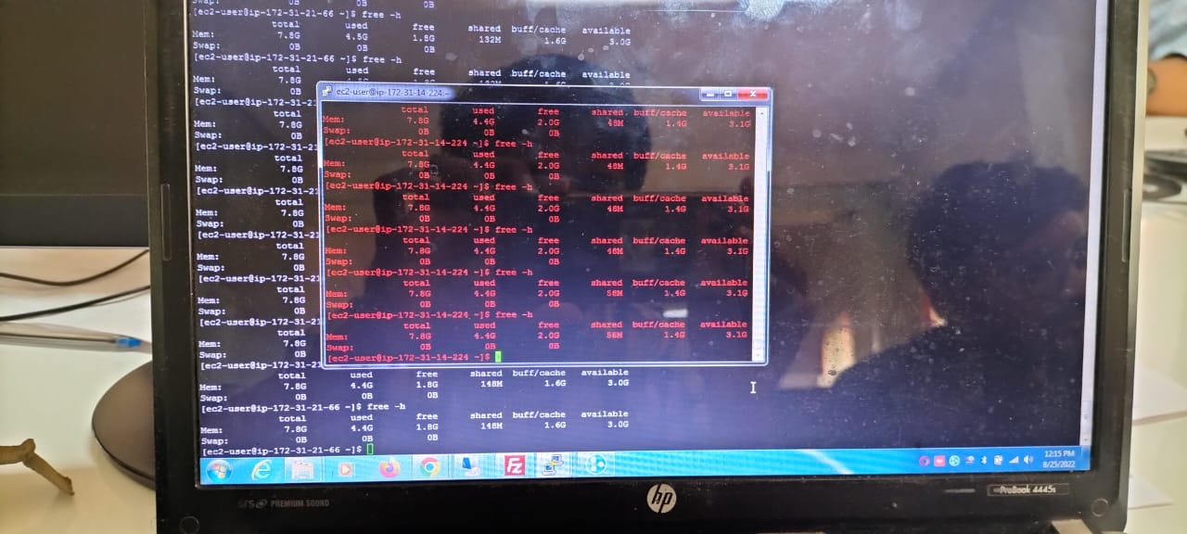

We can see that the port no’s of all the 4 jars are running in two servers.

